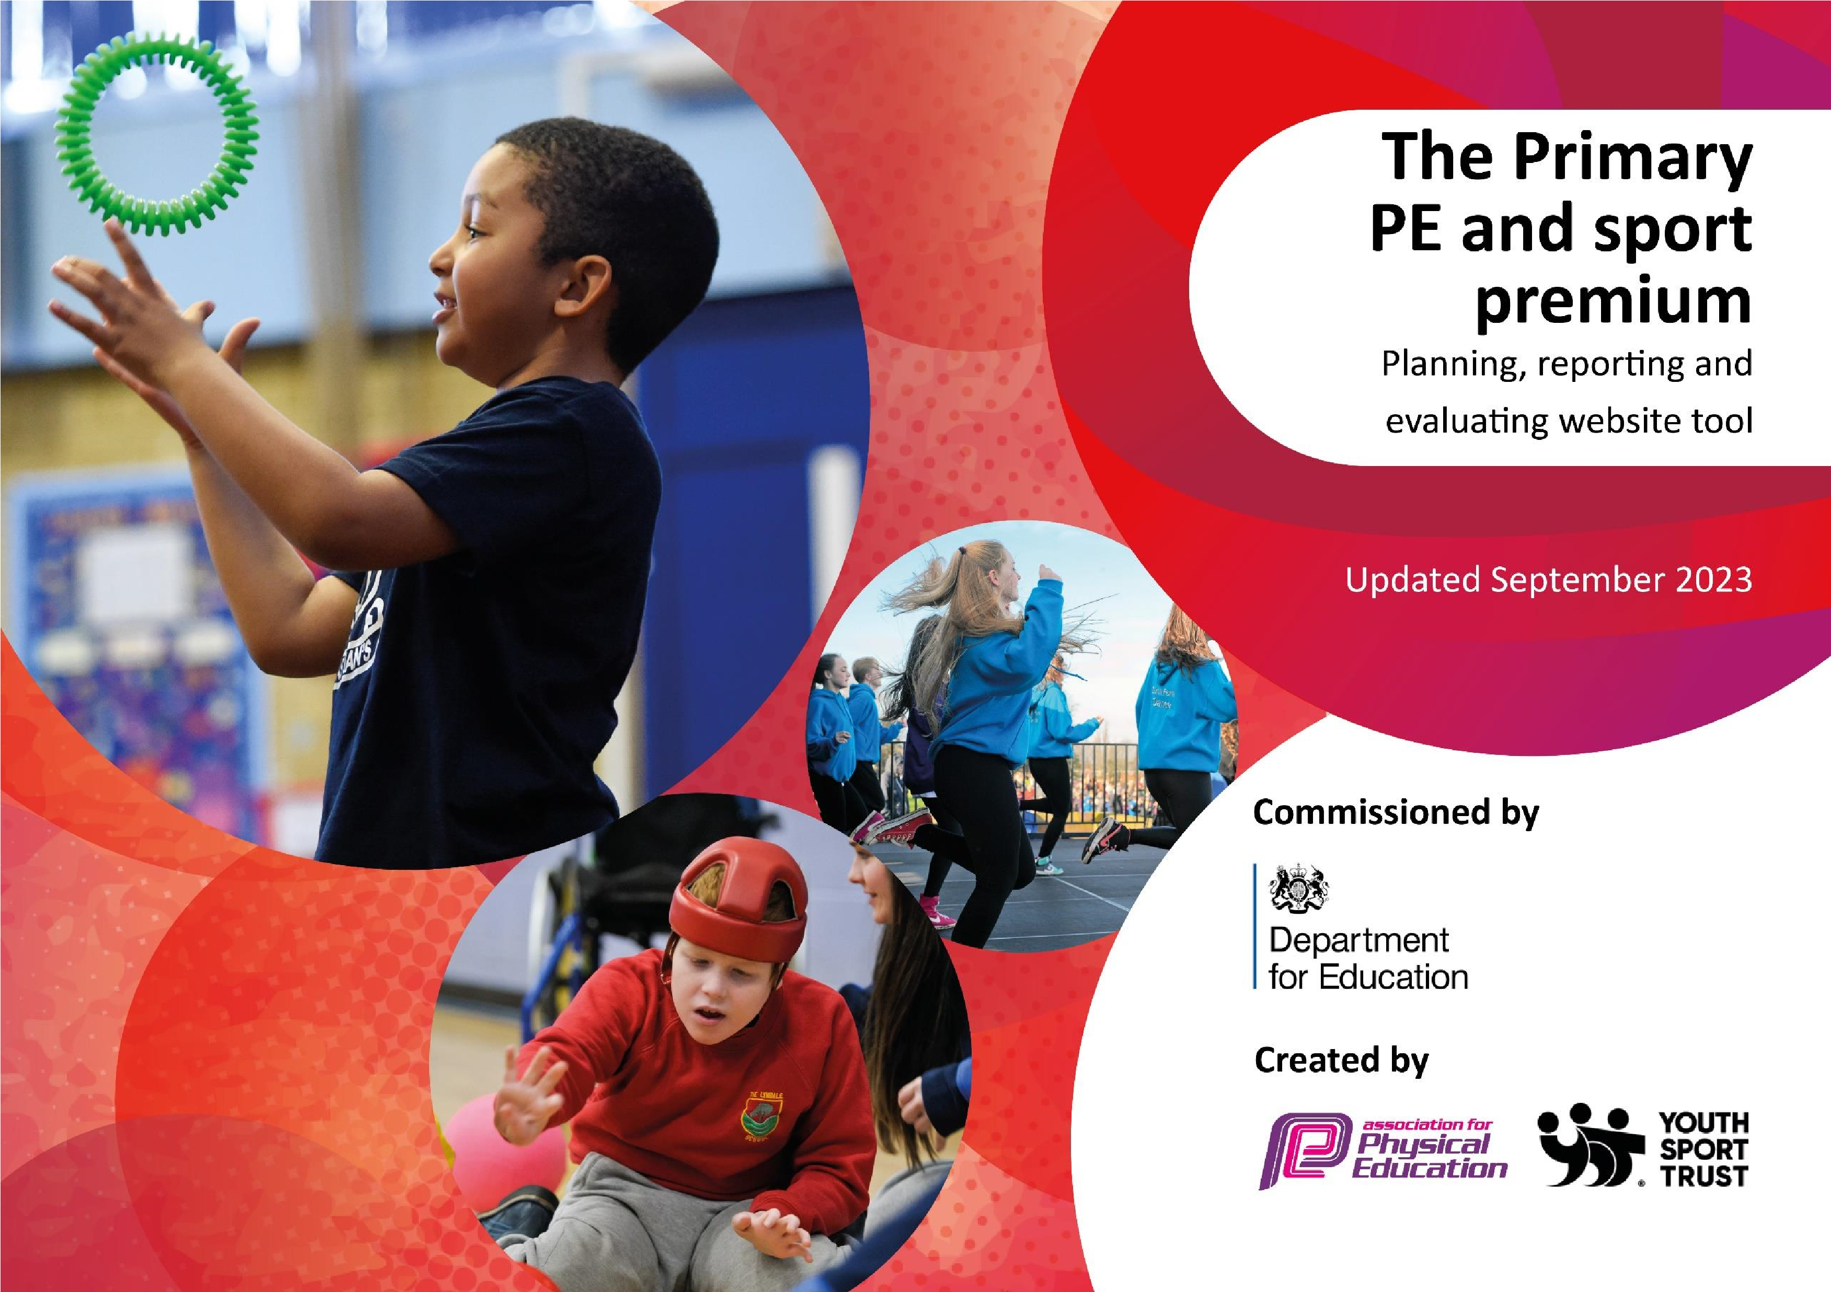

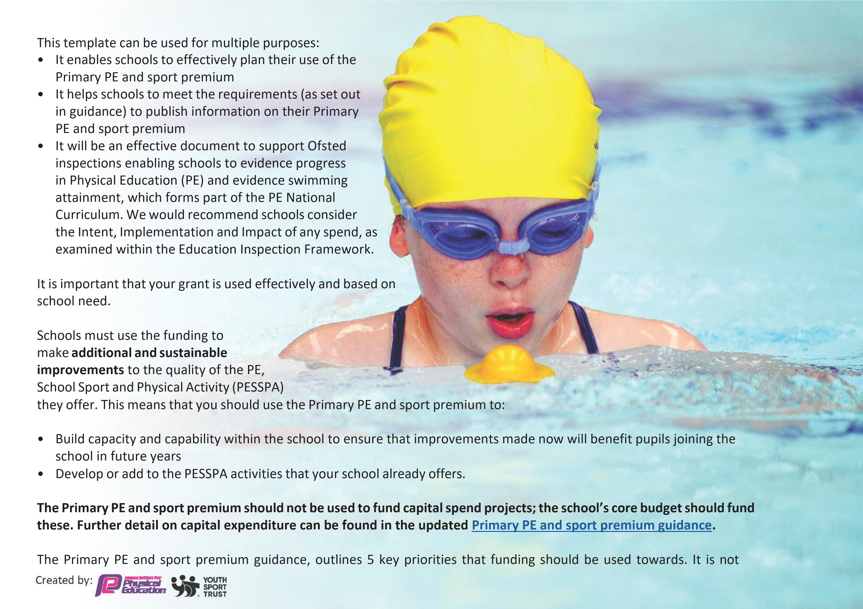
necessary that spending has to meet all the key priorities, you should select the priorities that you aim to use any funding towards.

Although completing this template is not a requirement for schools, schools are required to publish details of how they spend this funding. Schools must also outline what the impact this funding has had on pupils’ PE and sport participation and attainment and how any spending will be sustainable in the future. All funding must be spent by 31st July 2024.

Activity/Action | Impact | Comments
- After school clubs to continue to be organised for every term with the opportunity for all pupils to access clubs and achieve skills.  - Implement tasks and routines during the school day to increase physical activity – lunchtime club with PE activities  - SEND children to continue to attend SMILE competitions and festivals  - P.E. equipment has been improved. • Sports coaches have been utilised to focus on before/after school provisions and Holiday Camps.  - Additional swimming lessons have been provided for Yr 6 children who haven’t swam 25m. | - Attendance of pupils to afterschool clubs are over 90% uptake  - Planning reflects greater opportunities in place for pupils to be physically active throughout the school day, outside of PE lessons  - Children are achieving the CMO recommendation of at least 30 minutes of physical activity exercise.  - School has engaged with networking with schools within our MAC and beyond for extra curricular sports and competitions . | - We will continue to encourage the pupils to become involved through our exciting afterschool club opportunities.  - A review of equipment will be carried out by Sports Leaders and myself.  - Children unable to achieve 25m were given more opportunity and support to swim with an additional term of lessons.  - Learning mentor to continue to support with networking with schools within our MAC and beyond for extracurricular sports and competitions .

The Department for Education has worked closely with the Association for Physical Education (afPE) and the Youth Sport Trust (YST) to develop this template and encourages schools to use it. This template is an effective way of meeting the reporting requirements of the Primary PE and sport premium.

Review of last year’s spend and key achievements (2022/2023)

We recommend you start by reflecting on the impact of current provision and reviewing your previous spend.

- Children in KS2 were given the opportunity to take part in competitions.  - To implement the ABC rainbow Warrior programme to raise the profile of PE, physical activity and school sport  - To continue to provide ongoing professional development for teaching staff in all areas of the PE curriculum in order to continually improve provision for the PE curriculum taught across school - Subject leader time · Subject leader CPD  - Continue to provide a wide range of competitive and non-competitive sports clubs to increase the opportunities for the children to participate in physical activities.  - Ensure children are experiencing a wide range of competitive sport to develop an understanding of the importance of competition in sport | - Rainbow warriors invited to share success at local authority PE conference – viewed as a model of good practice  - Children experience a broad and balanced PE curriculum with a continued focus on SEND children.  - Curriculum overview agreed with VP/PE leader and sports provider ensuring knowledge and skills are developed  - · Increase the number of opportunities available to pupils to participate in extra-curricular activities  - · Identify where local sports clubs can support with increasing opportunities for our children to engage in physical activity  - School registered for a programme of competitions throughout the school year  - · Sport educator and teachers to promote opportunities for competitive sport through PE lessons and sharing the importance of competition • · Sport educator to support school by preparing pupils to participate | •  •  • | Staff continue to upskill in all areas of the PE curriculum and can lead/ team teach with coach on all areas of the curriculum under support from specialist coach.  Strive to increase the number of children accessing community sport Competitive sport with other schools and intra competitions to continue throughout the next year.

Key priorities and Planning

This planning template will allow schools to accurately plan their spending.

Action – what are you planning to do | Who does this action impact? | Key indicator to meet | Impacts and how  sustainability will be achieved? | Cost linked to the action
- To implement the WOW programme to  raise the profile of PE, physical agility and fitness.  - To continue the partnership with Premier  Education sports to support raining the profile PE in our school . | All pupils who take part including SEND pupils..  - Weekly CPD provided through SLA with  Premier Sports for 1 day per week.  - Children experience a broad and balanced PE  curriculum with a continued focus on SEND children | • Key indicator 1: The engagement of all pupils in regular physical activity – Chief Medical Officers guidelines recommend that primary school pupils undertake at least 30 minutes of physical activity a day in school  Key indicator 1: The engagement of all pupils in regular physical activity – Chief Medical Officers guidelines recommend that primary school pupils undertake at least 30 minutes of physical activity a day in school  Key indicator 2: The profile of  PESSPA being raised across the | More pupils meeting their daily physical activity goal, more pupils encouraged to take part in PE and Sport Activities.  • Increased teacher  knowledge and  confidence when delivering sport specific skills in line with the curriculum | £750 costs for additional coaches to support lunchtime sessions.  £7,000

- To continue to provide ongoing professional development for teaching staff in all areas of the PE curriculum in order to continually improve provision for the PE curriculum taught across school  - To continue to engage pupils in a variety of competitive sports for achievement | All teachers who have professional duty to teach PE.  All teachers who have professional duty to teach PE.  All pupils to participate.  Learning mentor and PE lead engagement through networking with the wider | school as a tool for whole school improvement  Key indicator 3: Increased confidence, knowledge and skills of all staff in teaching PE and sport  Key indicator 4: Broader experience of a range of sports and activities offered to all pupils  Key indicator 5: Increased participation in competitive sport  • Key indicator 4: Broader experience of a range of sports and activities offered to all pupils | - Pupil acquire the skills and knowledge to be able to engage in a wide variety of sports.  - Pupil acquire the skills and knowledge to be able to engage in a wide variety of sports. | £500 for CPD opportunities  Cost of transportation  £2,414

 | community in sports . | - Key indicator 2: The profile of PESSPA being raised across the school as  a tool for whole school  improvement  - Key indicator 3: Increased confidence, knowledge and skills of all staff in  teaching PE and sport  - Key indicator 4: Broader experience of a range of sports and activities offered to all pupils  - Key indicator 5: Increased participation in competitive sport

Key achievements 2023-2024

This template will be completed at the end of the academic year and will showcase the key achievements schools have made with their Primary PE and sport premium spending.

Activity/Action | Impact | Comments
- High quality PE curriculum established in partnership with Premier Education.  - WOW project introduced to support pupils’ health and fitness  - Wider range of sports covered via after school clubs an networking with the wider community.  - Success of competitive sports across the school .  - Working closer with our MAC schools through competitive sports . | Exposure to different sports. CPD for staff resulting in higher quality teaching and learning.  More pupils joining a variety of out of school clubs after being inspired at after school clubs.  Pupils are growing with confidence and self esteem to access all sports in a competitive manner. | A rise of confident children accessing a wider PE curriculum.  Higher % of children accessing extra curriculum sport activities .

Swimming Data

Meeting National Curriculum requirements for swimming and water safety.
Priority should always be given to ensuring that pupils can perform safe self-rescue even if they do not fully meet the first two requirements of the National Curriculum programme of study

Question | Stats: | Further context  Relative to local challenges
What percentage of your current Year 6 cohort can swim competently, confidently and proficiently over a distance of at least 25 metres? | 40% | A lot of the cohort of children do not partake in swimming lessons out of school.
What percentage of your current Year 6 cohort can use a range of strokes effectively [for example, front crawl, backstroke, and breaststroke]? | 77% | Over the two terms Year 6 attended swimming lessons, they grew in confident in both backstroke and front crawl.

What percentage of your current Year 6 cohort are able to perform safe self-rescue in different water-based situations? | 97%
If your schools swimming data is below national expectation, you can choose to use the Primary PE and sport premium to provide additional top-up sessions for those pupils that did not meet National Curriculum requirements after the completion of core lessons. Have you done this? | Yes/No | The whole of Year 6 had another half term of swimming lessons in Summer 2 to top-up their skills.
Have you provided CPD to improve the knowledge and confidence of staff to be able to teach swimming and water safety? | Yes/No | A member of staff has been trained to go into the pool and deliver one-to-one swimming lessons to our children.
Signed off by:

Head Teacher: | C. Hinton
Subject Leader or the individual responsible for the Primary PE and sport premium: | C. Hinton and L. Reaney
Governor: | Stephen Godber
Date: | 04.09.2024

